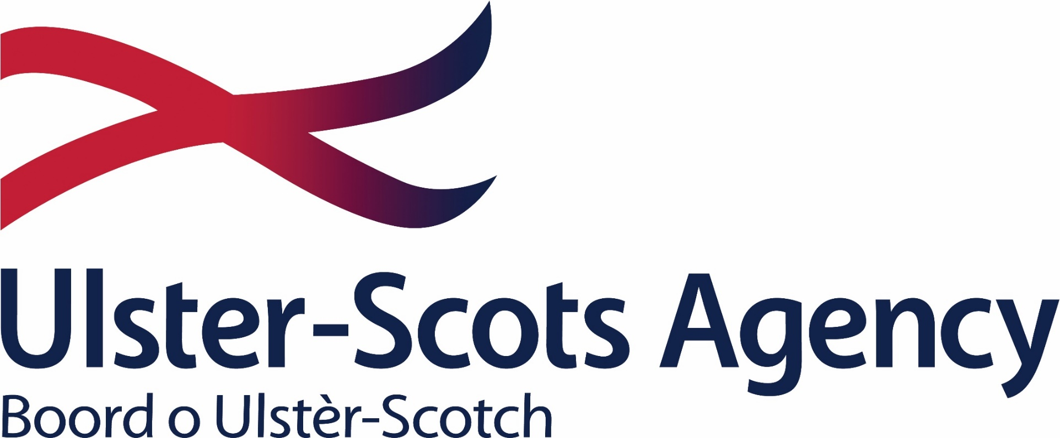

APPLICATION PACK
EDUCATION OFFICER
U-SA/EO/26 – JUNE 26

Closing date for receipt of applications: Sunday 26th July 2026

CONTENTS

- Application Form

- Equality Monitoring Form

- Process to submit your application

Section 1 – Application Form

- Personal Details (click on the grey text boxes to enter your information)
Title | Given Name(s) | Family Name
Click or tap here to enter text. | Click or tap here to enter text. | Click or tap here to enter text.
Prefer to be known as: | Click or tap here to enter text.
Address: | Click or tap here to enter text.
 | Click or tap here to enter text.
Town/City: | Click or tap here to enter text.
Post Code: | Click or tap here to enter text.
Contact Number: | Click or tap here to enter text.
Email Address: | Click or tap here to enter text.

- Right to Work
Are you currently resident in the UK or Ireland? | Yes ☐ | No ☐
Do you have (and can you provide confirmation of your) Right to Work (RTW) in the UK?
Please note you will be required to bring your evidence of RTW to the interview should you be shortlisted. If you are unable to bring this with you, we may not proceed with the interview.
Yes ☐ Yes, with sponsorship ☐ |  | No ☐

- Role Requirements
Are you educated to degree level or can demonstrate equivalent work experience? | Yes ☐ | No ☐
Our current hybrid arrangements require all staff to attend the office on Wednesdays and also one other rota’d day per week minimum. Please confirm that you would be able to attend the office as per our policy | Yes ☐ | No ☐
Can you demonstrate experience of the full cycle of design and delivery of a varied content of material in a wide range of settings? | Yes ☐ | No ☐
Can you demonstrate a strong understanding of the importance of continual improvement through evaluation of the impact of learning content and delivery methods? | Yes ☐ | No ☐
Can you demonstrate capacity to adapt your communication and presentation style to suit the audience? | Yes ☐ | No ☐

- Desirable Criteria
Can you demonstrate a working knowledge of curriculum delivery in either NI or ROI? | Yes ☐ | No ☐
Can you demonstrate a working knowledge of Ulster-Scots language? | Yes ☐ | No ☐
Do you have a full driving licence and access to a car? | Yes ☐ | No ☐
Please note, where the majority of applicants can satisfy the generic competency requirements, we may decide to shortlist for interview based on the desirable criteria above.
- Generic Competency Requirements
Please complete this section as fully as possible as we will shortlist for interview based on your responses within this section. Please ensure you read through the competencies within the NICS Competency Framework at level 3, which is analogous to this role, and ensure you provide sufficient evidence to demonstrate your competency at this level. You can find the competency framework here - nics-cf.pdf
STRATEGIC CLUSTER – SETTING DIRECTION
- Seeing the Big Picture: This is about having an in-depth understanding and knowledge of how your role fits with, and supports, organisational objectives and the wider public needs. How can you demonstrate capability of this within your current and/or previous roles?
Click or tap here to enter text.
- Changing and Improving: People who are effective in this area are responsive, innovative and seek out opportunities to create effective change. How can you demonstrate capability of this within your current and/or previous roles?
Click or tap here to enter text.
- Making Effective Decisions: Effectiveness in this area is about being objective, using sound judgement, evidence and knowledge to provide accurate, expert, and professional advice. How can you demonstrate capability of this within your current and/or previous roles?
Click or tap here to enter text.
PEOPLE CLUSTER – ENGAGING PEOPLE
- Leading and Communicating: Effectiveness in this area is about leading from the front and communicating with clarity, conviction and enthusiasm. It is about supporting principles of fairness of opportunity for all and a dedication to a diverse range of citizens. How can you demonstrate capability of this within your current and/or previous roles?
Click or tap here to enter text.
- Collaborating and Partnering: People skilled in this area create and maintain positive, professional and trusting working relationships with a wide range of people both within and outside of the organisation, to help achieve business objectives and goals. How can you demonstrate capability of this within your current and/or previous roles?
Click or tap here to enter text.
- Building Capability for All: Effectiveness in this area is having a strong focus on continuous learning for oneself, others and the organisation. How can you demonstrate capability of this within your current and/or previous roles?
Click or tap here to enter text.
PERFORMANCE CLUSTER – DELIVERING RESULTS
- Delivering value for money: This involves the efficient, effective and economic use of taxpayers’ money in the delivery of public services. How can you demonstrate capability of this within your current and/or previous roles?
Click or tap here to enter text.
- Managing a Quality Service: Effectiveness in this area is about being organised to deliver service objectives and striving to improve the quality of service, taking account of diverse customer needs and requirements. How can you demonstrate capability of this within your current and/or previous roles?
Click or tap here to enter text.
- Delivering at Pace: Effectiveness in this area means focusing on delivery timely performance with energy and taking responsibility and accountability for quality outcomes. How can you demonstrate capability of this within your current and/or previous roles?
Click or tap here to enter text.
- Achieving Outcomes through Delivery Partners: Being effective in this area is about maintaining an economic, long-term focus in all activities involving delivery partners (whether from the private, public, or voluntary sectors). How can you demonstrate capability of this within your current and/or previous roles?
Click or tap here to enter text.

Section 2 – Equality Monitoring Form

NOTE: THIS SECTION IS REMOVED FROM YOUR APPLICATION PRIOR TO ANY SHORTLISTING ACTIVITY AND IS PURELY FOR THE PURPOSES OF REGULATORY AND STATUTORY REPORTING AS REQUIRED BY LAW.
The Ulster-Scots Agency is committed to equality of opportunity for all candidates. As part of the North South Language Body, we are required to monitor and report in line with legislation on both sides of the border. To assist in this monitoring process, it is necessary to ask you a number of questions:
Date of Birth: | Click or tap here to enter text. | Sex: | Choose an item. | Marital Status: | Choose an item.
Community Background: To demonstrate our commitment to equality of opportunity in employment we need to monitor the community background of applicants, as required by the Fair Employment and Treatment (NI) Order 1998.
- I am a member of the Protestant Community |  |  |  | ☐
- I am a member of the Roman Catholic community |  |  |  | ☐
- I am a member of neither the Protestant nor the Roman Catholic community |  |  |  | ☐
Ethnicity: Please indicate to which of these ethnic groups you consider you belong.
White | ☐ | Irish Traveller | ☐ | Bangladeshi | ☐
Chinese | ☐ | Black African | ☐ | Pakistani | ☐
Indian | ☐ | Black Caribbean | ☐ | Mixed Ethnic Group | ☐
Filipino | ☐ | Black Other | ☐ | Prefer Not to Say | ☐
Any other Ethnic Group (please specify) |  |  | Click or tap here to enter text.
Disability: Do you consider yourself to have a disability as defined by the Disability Discrimination Act 1995 / 2005 Irish Disability Act
Yes ☐ | No ☐ | Prefer Not to Say | ☐
How did you find out about this job? |  | Indeed ☐ NIJobs ☐ Facebook ☐ LinkedIn ☐ Referral ☐ Our Website ☐
Section 3 – Application Process

Congratulations on completing your application so far! Now all you need to do is save this document, attach it along with your CV to an email and send to pknowles@ulsterscotsagency.org.uk.
What happens next….
Upon receipt of your application, it will be reviewed to ensure you meet all the basic eligibility criteria (section C of the application form). Provided this is met, the Equality Monitoring section will be removed and stored separately for future reporting purposes, and your application will be anonymised in readiness for the shortlisting process.
Should you not be successful at any stage of the process, we will provide you with feedback.
In terms of GDPR, we will only retain any data needed for statutory reporting purposes beyond 6 months after the time of application.
Please note, there is a reference code at the bottom left hand corner of this document – should you need to get in touch with us regarding your application at any point, please quote this reference.
Good luck with your application and we will be in touch soon!

